**MACRO NUTRIENTS:**

**NITROGEN, POTASSIUM, PHOSPHOROUS**

**Whisker plot:** 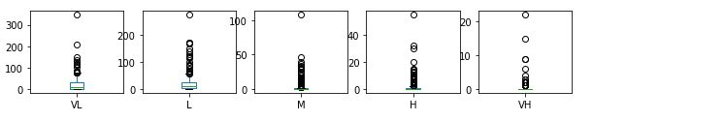

**Outputs the histogram plot:**

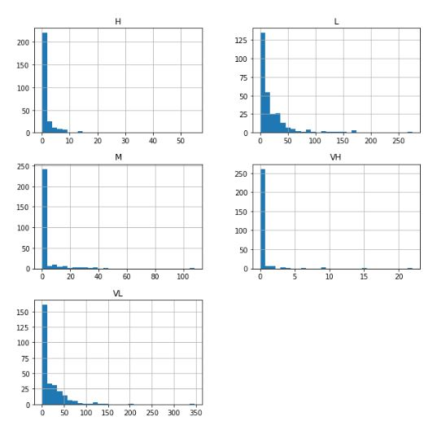

**Class**

Potassium 94

Nitrogen 94

Phosporous 94

dtype: int64

Accuracy of Logistic regression classifier on training set:0.71 Accuracy of Logistic regression classifier on test set:0.74

Accuracy of Decision Tree classifier on training set: 1.0

Accuracy of Decision Tree classifier on test set: 0.8

Accuracy of K-NN classifier on training set: 0.8

Accuracy of K-NN classifier on test set: 0.7

Accuracy of GNB classifier on training set: 0.6

Accuracy of GNB classifier on test set: 0.6

Automatically created module for IPython interactive environment Accuracy of SVM classifier on training set: 0.5

Accuracy of SVM classifier on test set: 0.5

Accuracy Score: 0.5263157894736842

[[17 2 0]

[ 0 13 6]

[ 1 6 12]]

precision recall f1-score support

Potassium 0.94 0.89 0.92 19

Nitrogen 0.62 0.68 0.65 19

Phosporous 0.67 0.63 0.65 19

accuracy 0.74 57

macro avg 0.74 0.74 0.74 57

weighted avg 0.74 0.74 0.74 57

**Random Forest Classifier:**

Confusion Matrix:

[[18 1 0]

[ 0 14 5]

[ 1 6 12]]

Classification Report:

precision recall f1-score support

Potassium 0.95 0.95 0.95 19

Nitrogen 0.67 0.74 0.70 19

Phosporous 0.71 0.63 0.67 19

accuracy 0.77 57

macro avg 0.77 0.77 0.77 57

weighted avg 0.77 0.77 0.77 57

Accuracy: 0.7719298245614035.

**Micro nutrients**

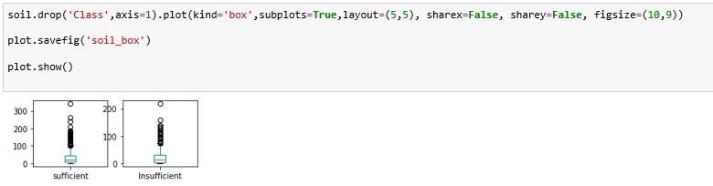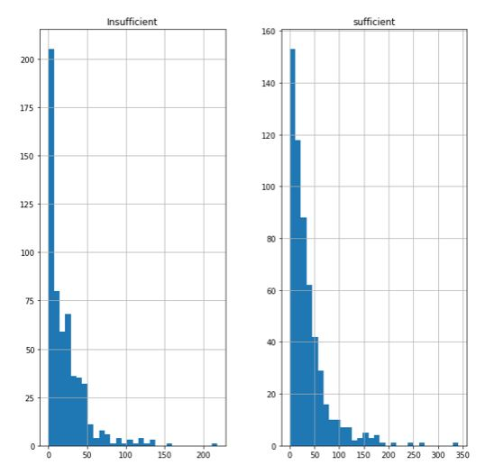

Class

B 94

Cu 94

Fe 94

Mn 94

S 94

Zn 94

dtype: int64

Accuracy of Logistic regression classifier on training set:0.35 Accuracy of Logistic regression classifier on test set:0.33

Accuracy of Decision Tree classifier on training set: 0.9

Accuracy of Decision Tree classifier on test set: 0.2

Accuracy of K-NN classifier on training set: 0.5

Accuracy of K-NN classifier on test set: 0.3

Accuracy of GNB classifier on training set: 0.3

Accuracy of GNB classifier on test set: 0.3

Accuracy of SVM classifier on training set: 0.3

Accuracy of SVM classifier on test set: 0.2

Accuracy Score: 0.22123893805309736

[[ 2 5 3 5 0 1]

[ 5 12 0 2 2 2]

[ 5 0 6 0 1 0]

[ 3 1 3 4 4 2]

[ 3 2 4 7 4 7]

[ 3 4 0 4 3 4]]

precision recall f1-score support

B 0.10 0.12 0.11 16

Cu 0.50 0.52 0.51 23

Fe 0.38 0.50 0.43 12

Mn 0.18 0.24 0.21 17

S 0.29 0.15 0.20 27

Zn 0.25 0.22 0.24 18

accuracy 0.28 113

macro avg 0.28 0.29 0.28 113

weighted avg 0.29 0.28 0.28 113

**Confusion Matrix:**

[[ 1 4 3 5 1 2]

[ 3 13 0 2 3 2]

[ 7 0 2 2 1 0]

[ 2 1 2 4 3 5]

[ 4 1 4 9 3 6]

[ 2 5 0 3 5 3]]

Classification Report:

precision recall f1-score support

B 0.05 0.06 0.06 16

Cu 0.54 0.57 0.55 23

Fe 0.18 0.17 0.17 12

Mn 0.16 0.24 0.19 17

S 0.19 0.11 0.14 27

Zn 0.17 0.17 0.17 18

accuracy 0.23 113

macro avg 0.22 0.22 0.21 113

weighted avg 0.23 0.23 0.23 113

Accuracy: 0.23008849557522124

**PH and OC:**

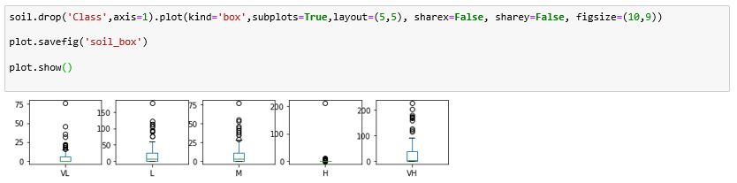

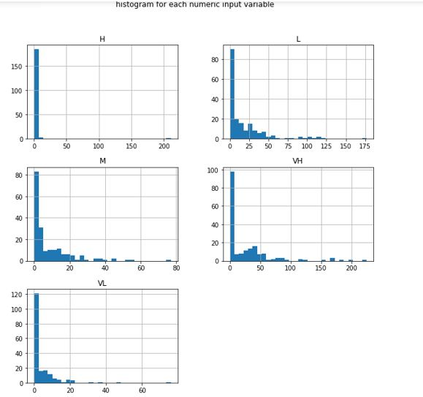

Class

OC 94

PH 94

dtype: int64

Accuracy of Logistic regression classifier on training set:0.97 Accuracy of Logistic regression classifier on test set:0.97

Accuracy of Decision Tree classifier on training set: 1.0

Accuracy of Decision Tree classifier on test set: 1.0

Accuracy of K-NN classifier on training set: 1.0

Accuracy of K-NN classifier on test set: 0.9

Accuracy of GNB classifier on training set: 1.0

Accuracy of GNB classifier on test set: 0.9

Accuracy of SVM classifier on training set: 1.0

Accuracy of SVM classifier on test set: 0.9

Accuracy Score: 0.9473684210526315

[[17 1]

[ 1 19]]

precision recall f1-score support

OC 0.94 0.94 0.94 18

PH 0.95 0.95 0.95 20

accuracy 0.95 38

macro avg 0.95 0.95 0.95 38

weighted avg 0.95 0.95 0.95 38

**Confusion Matrix:**

[[18 0]

[ 1 19]]

**Classification Report:**

precision recall f1-score support

OC 0.95 1.00 0.97 18

PH 1.00 0.95 0.97 20

accuracy 0.97 38

macro avg 0.97 0.97 0.97 38

weighted avg 0.98 0.97 0.97 38

Accuracy: 0.9736842105263158.